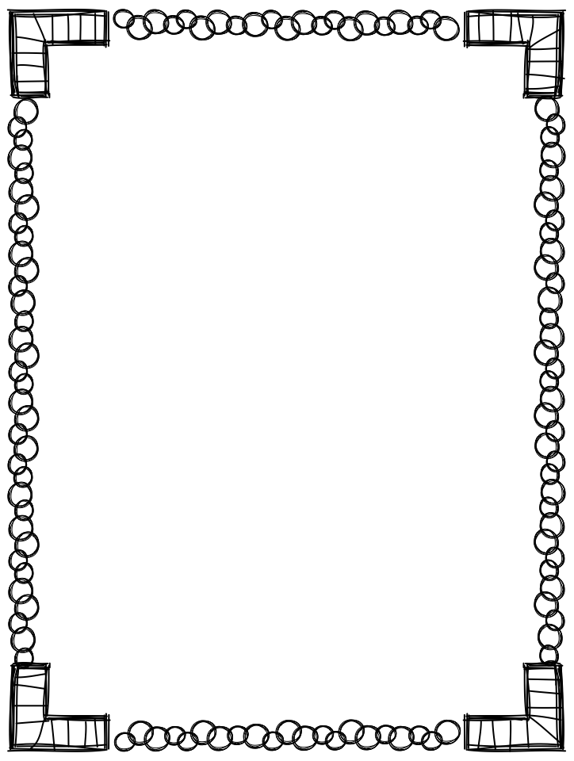
Dear Parents and Guardians,
Hello, my name is Karlee Corrado and I am delighted to be your student’s teacher for the 2017-2018 school year! I graduated from Georgia College and State University in May 2015 with my teaching degree in early childhood education. I grew up in Kennesaw, Georgia, and attended Cobb County schools. In my free time I love to watch movies, explore new cities, and spend time with my family. I am thrilled to be a part of the family at Sanders Elementary School.
Kindergarten is an exciting year for your student, although he/she may be a little apprehensive about going to “real” school. This is also a time of mixed emotions for parents – joy that your child is ready for school, but sadness because he/she is no longer a “baby.” The first day of school will mark one of the most important milestones in your child’s life.
Be assured that I will do my best to make this school year an enjoyable time for your child, but also a time filled with real learning. Please do not think your child will be just “playing” all day! What may appear as games when you enter the classroom are actually activities that provide daily practice in the skills, which are the building blocks for your child’s future success in school.
When family members are involved in their children’s education, children succeed at higher rates. I would love for you to be involved in the classroom. Here are a just a couple ways to make that happen: become a class parent, read to the class, be a guest speaker, or chaperone events.
In case of emergency, please call the school’s number – (770) 819-2568. If you have a question or concern you can contact me by email at karleecorrado@cobbk12.org or through the Remind app.
I want you to be as involved as you can be in your student’s education. I will be sending home a homework packet each week that lists anything currently happening or upcoming in the classroom. There will be reminders on the letter for any special events going on throughout the year. Homework will go home each week on Monday and is due back to school on that Friday. Please help your student complete the homework and make sure that it is signed and returned each week in their folder so that we can check it.
We follow the school-wide PBIS plan or Positive Behavioral Interventions and Supports. This is a support system that includes proactive strategies for defining, teaching, and supporting appropriate student behaviors to create positive school environments. In addition to the school-wide behavior plan, I will implement classroom management strategies of my own. Students will be encouraged to remain on task in order to earn “quiet critters” and will be encouraged to tattle only to the “tattle tale monster.” Any communication regarding behavior will be done through your child’s agenda. Please sign and return to school each day.

I look forward to working with you and your student this year!
Ms. Corrado r
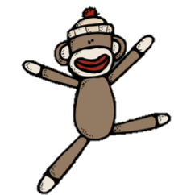

Kindergarten Curriculum Overview
- Literacy and Phonics
  - Identify the front, back, title, and author of a book
  - Make predictions
  - Demonstrate comprehension of stories by orally retelling or acting out a story
  - Blend CVC sounds aloud to make a word (e.g., log, cat, pup)
  - Rhyming words
  - Identify main ideas and supporting details
  - Print alphabet letters without a model
  - Read and write from left to right and top to bottom

- Math
  - Count to 100 by 1’s, 2’s, 5’s, and 10’s
  - Demonstrate one to one correspondence when counting
  - Sort and classify objects by position, size, shape, color, etc.
  - Identify 2D and 3D shapes
  - Add and subtract within 20
  - Collect, sort, and interpret data in various graphs

- Social Studies
  - Learn about self, family, and friends
  - Understand parts of a community and community helpers
  - American history and holidays (e.g., Thanksgiving, Martin Luther King Jr., etc.)
  - Locate hometown on a map
  - Appreciate diversity among cultures in the community

- Science
  - Sort living organisms and non-living materials into groups
  - Compare similarities and differences in groups of organisms
  - Investigate different types of motion
  - Explore the effects of gravity on objects
  - Describe objects based on what they are made of and their physical properties
  - Describe the physical attributes of rocks and soil

- Social Skills
  - Take care of desk materials
  - Work independently and in a group
  - Listen and follow directions
  - Use self control to follow classroom procedures

- Fine/Gross Motor Skills
  - Hold and manipulate pencils and scissors
  - Cut on lines
  - Hops, jumps, marches, skips, and dances

Resources

- Community Resources to support education and development
  - Sweetwater Valley Library
500 Austell Powder Springs Rd SW #123, Austell, GA 30106
  - South Cobb Regional Library
805 Clay Rd, Mableton, GA 30126
  - Powder Springs Library
4181 Atlanta St, Powder Springs, GA 30127
  - Tramore Park
2150 East-West Connector, Marietta, GA 30008
  - Legion Field
5514 Austell Powder Springs Rd, Austell, GA 30106

- Educational Websites
  - http://www.abcya.com/kindergarten_computers.htm
  - http://www.funbrain.com/kidscenter.html
  - http://www.roomrecess.com/
  - http://www.turtlediary.com/
  - http://www.pbskids.org/
  - http://www.brainpopjr.com/free/

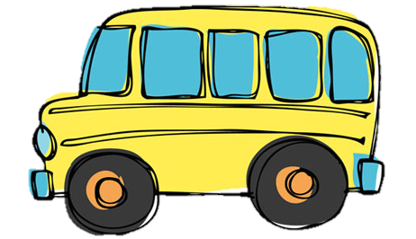

Dear Parents/Guardians,

Your child’s success is of the utmost importance as we begin the new school year. Please lend a hand by taking a few minutes to jot down some thoughts about the following items as they relate to your child.

Thank you for your insights and your time.

-----------------------------------------------------------------------------------------------------

My Name:

My Child’s Name:

Three words which describe my child:

Three words others would use to describe my child:

My child’s best feature:

My child’s favorite expression:

My child’s best friend:

My child’s favorite food:

A chore my child likes:

A chore my child dislikes:

Something my child enjoys doing at home:

Someone my child looks up to:

My child’s favorite sport:

My child’s academic strengths:

My child’s academic weaknesses:

A television character my child likes:

My child’s special talents:

My child’s fears and insecurities:

My child’s favorite book:

Something I would like to do for my family:

It is important for my child’s teacher to:

** Anything else you would like to tell me:

Kindergarten Supply List
- Backpack (no rolling backpacks)
- 2 large boxes of tissues
- 1 box of #2 pencils
- 6 JUMBO glue sticks
- 1 pack of block erasers
- 1 pair of scissors
- 4 spiral composition notebooks
- 2 hand sanitizers
- 2 containers of disinfecting wipes
- 3 boxes of Crayola crayons (24 pack)
- 1 pack Crayola washable markers
- 1 box of Band-Aids
- 1 container baby wipes
- 2 containers of Play-Doh (no magic dough)
- 3 plastic folders with pockets and prongs
- Girls: Index cards, 2 hand sanitizers, 2 boxes of gallon sized baggies
- Boys: Post it notes, 2 hand soaps, 2 boxes of quart sized baggies

- ETRAS
- White copy paper
- Construction paper (9x12 and/or 12x18)
- Water color paints
- Dry erase markers

